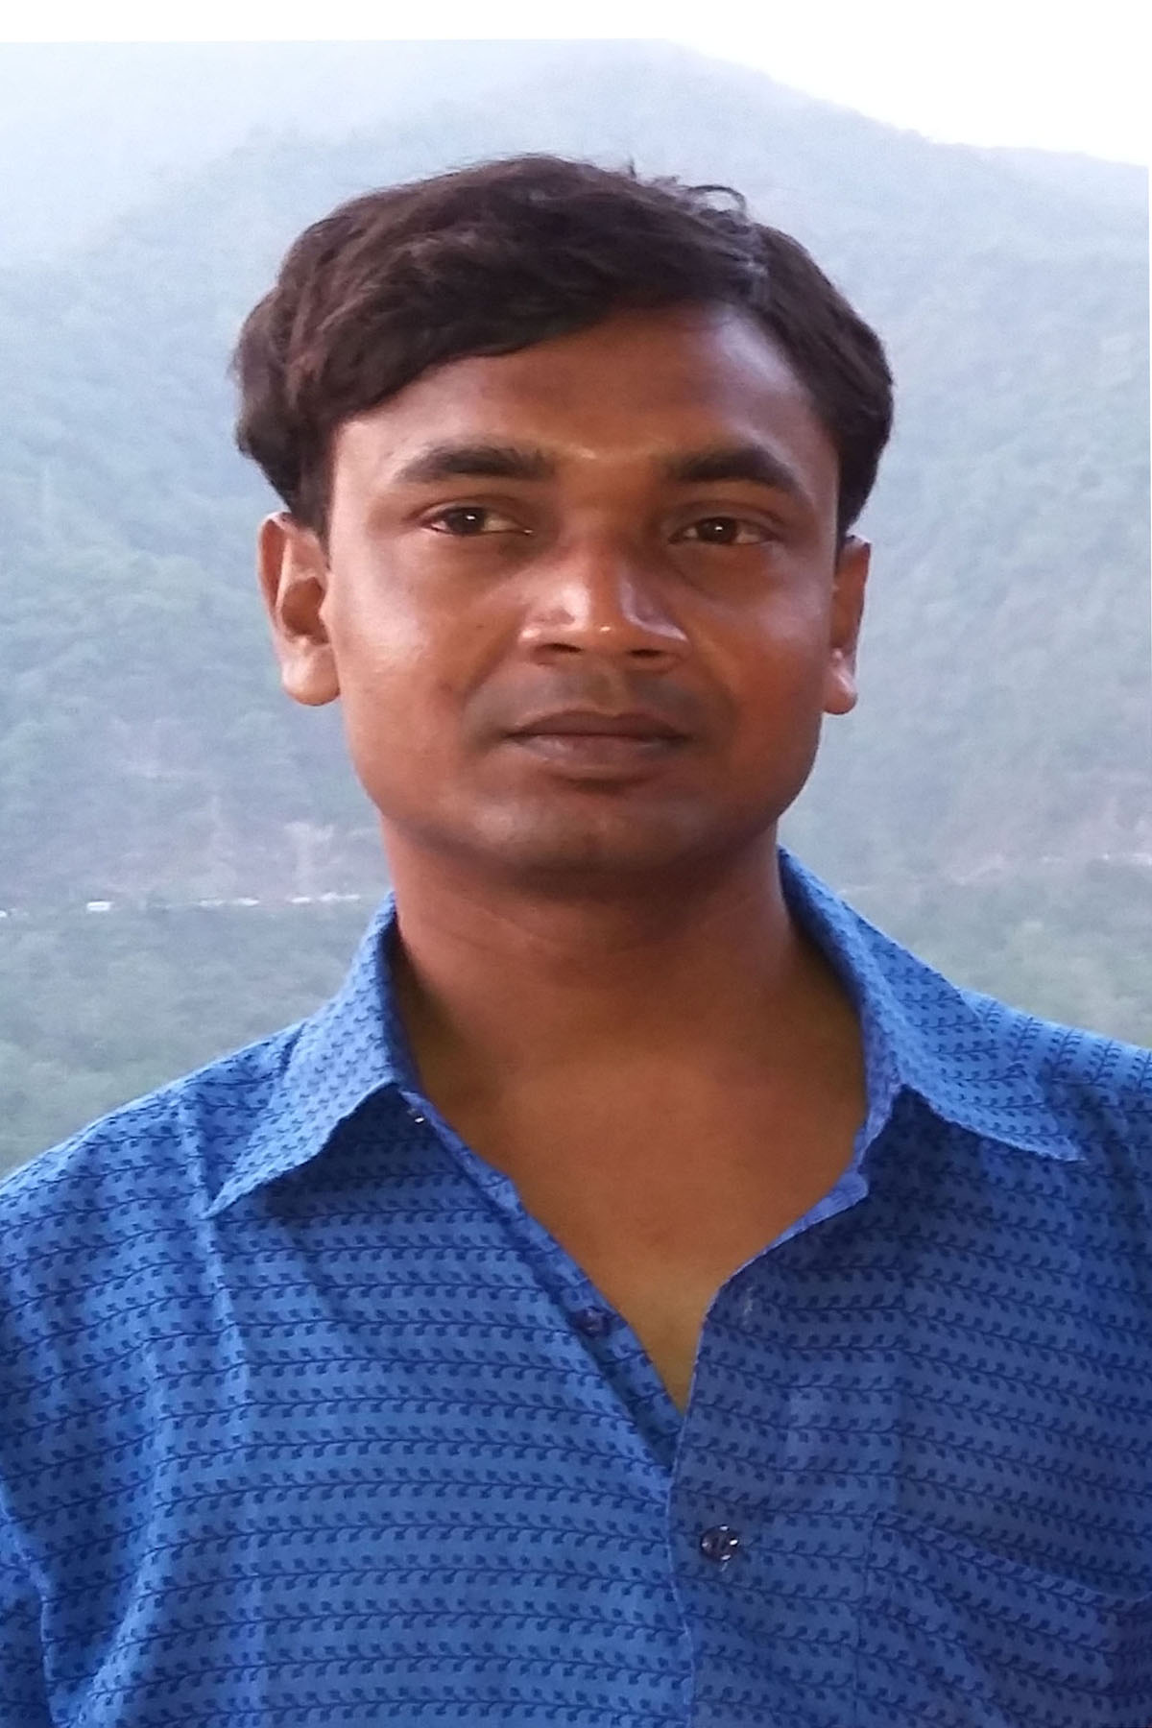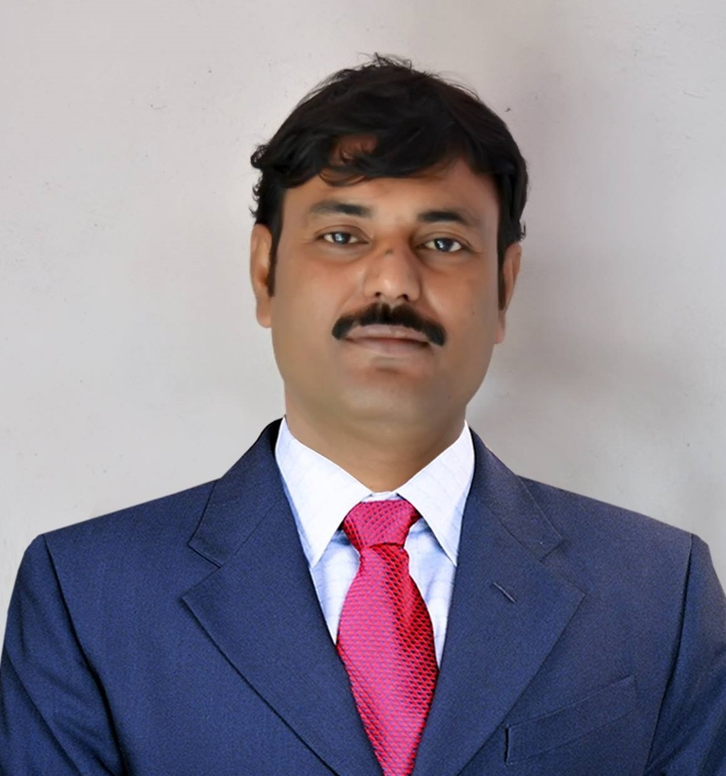 | Mr. Swapan Mal  Assistant Professor of Sanskrit
Academic Qualifications:
Madhyamik with Bengali, English, History, Geography, Life Science, Physical Science,

Mathematics, Work Education & Physical Education from WBBSE in 2001.

Higher Secondary with Bengali, English, Philosophy, Political Science, History & Sanskrit from

WBCHSE in 2003.

B.A. with Sanskrit (Hon’s), Education, English, Bengali & Tagore Studies from Visva Bharati, Santiniketan in 2007.

M. A. in Sanskrit from Visva Bharati, Santiniketan in 2009.

Ph.D.Submitted in Sanskrit from Visva Bharati, Santiniketan in 2017.

NET in Sanskrit in 24th June, 2012.

NET in Sanskrit in 30th December, 2012.

NET in Sanskrit in 30th June, 2013.
Contact Address:
Permanent: Vill- Chhora, P.O. – Bhuera, P.S. – Aushgram; Sub.Div. – Burdwan Sadar, Dist. – Purba Bardhaman; West Bengal; Pin- 713152

Email: swapanmalvb@gmail.com
Phone numbers: (+91)8927062782

Present: Dept. of Sanskrit , Raiganj University, P.O. & P.S. – Raiganj, Dist. – Uttar Dinajpur, West Bengal, Pin – 733134

Email: swapanmalvb@gmail.com
Phone numbers: (+91)8927062782

Research Interest:
- Samkhya & Yoga Philosophy
- Vedanta Philosophy
- Nyaya & Vaisheshika Philosophy
- Neo-Vedantaism
- Buddhism
- Jainism
- Charvaka Philosophy
- Tantra & Saivism
- Philosophy of the Vedas
- Philosophy of the Upanishads
- Philosophy of the Modern Sanskrit Literature
- Philosophy of the Classical Sanskrit Literature
- Philosophy of the Grammar
- Philosophy of the Puranas
- Philosophy of Bhakti
- Vaishnava Literature
- Manuscriptology
- Trends of Sanskrit Literature
- Smritisastras
- Comparative Literature
- Folk-Lore

Specialization: Charvaka, Jainism, Buddhism, Samkhya, Yoga, Nyaya, Vaisheshika, Purva Mimamsa, Vedanta, Saivism, Tantrism.

Conference/Seminar/Workshop:
- INTERNATIONAL

- Paper Presented:
- The title of paper “Rabindranatha-Vivekanandayormanane Bhaktibhavana” which is presented in the Conference of 47th Session of All India Oriental Conference, 2nd - 4th January, 2015, Deptt. of Sanskrit, Guahati University, Assam, India.

- The title of paper “Samajtattvik Drishtite Madhusudaner Patravali : Ekti Samiksha” which is presented in the Seminar on Chithipatre samaj O Sahitya, 27th March, 2015, Bankimchandra Centre of Comparative Indian Literature and Hindi Deptt., Rabindra Bharati University, Kolkata, W.B.

- The title of paper “Itihaser Dharay Navavedantavad O Bankimchandra Chattopadhyay” which is presented in the Seminar on The Renaissance Across Continents and Cultures : A Trans-disciplinary Perspective, 9th January, 2016, Deptt. of English, Samsi College, Malda, W.B.

- The title of paper “Bharatiya Darshane Paribeshchinta : Ek Paryalochana” which is presented in the Seminar on Environmental Degradation Due to Human Interference, 06, 07 & 08th March, 2016, Deptt. of Geography, Raiganj University, W.B.

- The title of paper “Bharatiyaitihyam Rabindranathashcha” which is presented in the Seminar on Influence of Sanskrit on Indian Culture, 11th March, 2016, Deptt. of Sanskrit, Raiganj University, W.B.

- The title of paper “Lokayata Darshane Dharma O Samajtattvasamiksha” which is presented in the Seminar on Philosophy, Religion and Society, 12th March, 2016, Deptt. of Philosophy, Raiganj University, W.B.

- The title of paper “svetasvataropanishad : Arthasphurane Bhashyanam Gurutvam” which is presented in the Seminar on Importance of Commentaries for Understanding Sanskrit Text, 5th-6th April, 2017, Deptt. of Sanskrit, University of Gour Banga, W.B.

- Organizer and convener:
- Influence of Sanskrit on Indian Culture, 11th March, 2016, Deptt. of Sanskrit, Raiganj University, W.B.

- Chairperson of Technical Session:
- Influence of Sanskrit on Indian Culture, 11th March, 2016, Deptt. of Sanskrit, Raiganj University, W.B.

- Treasurer:
- Environmental Degradation Due to Human Interference, 06, 07 & 08th March, 2016, Deptt. of Geography, Raiganj University, W.B.

- NATIONAL:

- Attended:
- Two Day National Seminar on Gnomic and Didactic Literature in Sanskrit, 08 & 09th March, 2013, Deptt. of Sanskrit, Pali & Prakrit, Visva Bharati, Santiniketan, W. B.

- Three Day National Workshop on Research Methodology in Sanskrit, 5th-07th December, 2014, Deptt. of Sanskrit, Pali and Prakrit, Visva Bharati, Santiniketan, W.B.

- Paper Presented:
- The title of paper “Svetasvataropanishad : Prasanga Samajabhavana” which is presented in the Seminar on Society and Culture inAncient Literature : A Retrospective Enquary, 31st March & 01st April, 2014, Deptt. of Sanskrit, The University of Burdwan, W.B.

- The title of paper “Bhaktivader Aloke Bankimchandra” which is presented in the Seminar on Reappraisal of Different Branches of Sanskritic Wisdom, 19th September, 2014, Deptt. of Sanskrit, University of Gour Banga, W.B.

- The title of paper “Sanskritasahityer Upar Bangla Sahityer Prabhav” which is presented in the Seminar on Bharatiya Sahitya par Bangla Sahitya ka Prabhav, 13th & 14th November, 2014, Akhil Bharatiya Sahitya Parishad, New Delhi, India.

- The title of paper “Svetasvataropanishadi Pratiphalita Upadeshamritah : Eka Samiksha” which is presented in the Seminar on Sanskritasahityasya Upadesha, 12th February, 2015, Deptt. of Sanskrit, Samsi College, Malda, W.B.

- The title of paper “Svetasvataropanishadi Pratiphalitachittashuddherupayah : Eka Samiksha” which is presented in the Seminar on Cleanliness and Holistic Health in Sanskrit Tradition, 13th & 14th February, 2015, Deptt. of Sanskrit, Pali & Prakrit, Visva Bharati, Santiniketan, W.B.

- The title of paper “Ancient Literature, Culture and Rabindranath : A Critical Study” which is presented in the Seminar on Translation and reception of Indian Literature : Its Role in National Culture, 26th & 27th February, 2015, Assamese Language Unit, Visva Bharati, santiniketan, W.B.

- The title of paper “Premendra Mitrer Hariye Kavita : Darshanik Drishtite” which is presented in the Seminar on Challish-Panchass Dashaker Bangali Jiban O Bangla Sahitya, 11th & 12th March, 2015, Deptt. of Bengali, North Bengal University, W.B.

- The title of paper “Adhunik Sanskrit Sahitye Bankimrachanavali” which is presented in the Seminar on Modern Indian Literature, 17th & 18th March, 2015, Deptt. of Bengali, Rabindra Bharati University, W.B.

- The title of paper “Tukkha Gane Aupanishadiktattver Suluksandhan” which is presented in the Seminar on Different Horizons of Lokosangskriti, 2nd & 3rd May, 2015, Raiganj Surendranath Mahavidyalaya, Uttar Dinajpur, W.B.

- The title of paper “Yoga theory in the Svetasvataropanishad : A Study” which is presented in the Seminar on Yoga : An Answer to Modern Health Hazards, 21st June, 2015, Deptt. of Sanskrit, Pali & Prakrit, Visva Bharati, Santiniketan, W.B.

- The title of paper “Bankimchandra O Navavedantavada : Ekti Tulanamulak Alochana” which is presented in the Seminar on Comparative Indian Literature, 26th June, 2015, Bankimchandra centre for Comparative Indian Literature, Rabindra Bharati University, W.B.

- The title of paper “Samskrita Sahityer Anuvadamukhidhara” which is presented in the Seminar on Trends and Developments in Science, Social Science & Humanities, 22th August, 2015, Islampur College, Islampur, Uttar Dinajpur, W.B.

- The title of paper “Rabindramanase Svetasvataropanishad : Ekti Samiksha” which is presented in the Seminar on Sanskrit and Rabindranath, 23rd August, 2015, Deptt. of Saskrit, Pali & Prakrit, Visva Bharati, Santiniketan, W.B.

- Ramkrishna O Vivekananda : Prasanga Visvajanin DharmaNeo-Vedantism : Contributions of Sri Ramkrishna and Vivekananda, 11th & 12th September, 2015, Deptt. of Philosophy, Dewan Abdul Gani College, South Dinajpur, W.B.

- The title of paper “Nyayadarshane Prameyatattvasamiksha” which is presented in the Seminar on Dimensions of Sanskrit Literature, 10th January, 2016, Deptt. of Sanskrit, Raiganj University, W.B.

- The title of paper “Concept of Socio-Economoc Status in Modern Sanskrit Plays” which is presented in the Seminar on Socio-Economic Challenges of West Bengal after Partition of India, 17th & 18th March, 2016, Deptt. of History, Raiganj University, W.B.

- The title of paper “Concept of International Relationship between Two States in Arthasastra” which is presented in the Seminar on Indian Polity at the Crossroads, 28th March, 2016, Deptt. of Political Science, Raiganj University, W.B.

- The title of paper “Bankimchandra O Samkhyadarshan : Ek Samiksha” which is presented in the Seminar on The Sanskrit and Bengali Literature in the Light of the Philosophy : From Source to Modernization, Rampurhat College, Birbhum, W.B.

- The title of paper “Upanishadi Pratiphalitah Manavatavada : Eka Samiksha” which is presented in the Seminar on Humanism in Sanskrit Literature, 10th March, 2017, Deptt. of Sanskrit, Raiganj University, W.B.

- Organizer and convener:
- Dimensions of Sanskrit Literature, 10th January, 2016, Deptt. of Sanskrit, Raiganj University, W.B.

- Humanism in Sanskrit Literature, 10th March, 2017, Deptt. of Sanskrit, Raiganj University, W.B.

- Chairperson of Technical Session:
- Dimensions of Sanskrit Literature, 10th January, 2016, Deptt. of Sanskrit, Raiganj University, W.B.

ii.Humanism in Sanskrit Literature, 10th March, 2017, Deptt. of Sanskrit, Raiganj
University, W.B.

- STATE LEVEL:

- Attended:
- One Day Seminar on Inland Aquaculture and present Scenario of West Bengal, 06th June, 2015, Deptt. of Zoology, Raiganj University, W.B.

- Presented:
- The title of paper “Samskritasya Sampratiki Parasangikata” which is presented in the Seminar on Sanskrit in School Curriculum : Issues and Challenges, 08th November, 2015, All Bengal Sanskrit Lovers’ Association, Murshidabad District Committee, W.B.

- ORIENTATION PROGRAMME:

- Attended:
- Orientation Programme (28th OP at NBU), 23rd November to 20th December, 2016, Human Resource Development Centre, University of North Bengal, W.B.

Research Experience:
Total Research Experience about 05 Years

Ph.D. submitted in the Dept. of Sanskrit, Pali & Prakrit, Bhasha Bhavana, Visva Bharati, Santiniketan from 2013 to 2017.
Previous & Present Employment:

Assistant Professor, Raiganj College(University College), Raiganj, Uttar Dinajpur, from 04th August, 2014 to 2nd February, 2015

Assistant Professor, Raiganj University, Raiganj, Uttar Dinajpur, from 3rd February, 2015 to Till continue
Administrative Experience:
Coordinator, Dept. of Sanskrit, Raiganj University, Uttar Dinajpur, W.B.

Chairman of Board Of Studies (Under Graduate & Post Graduate), Dept. of Sanskrit, Raiganj University, Uttar Dinajpur, W.B.

Chairman of Board of Research Studies, Dept. of Sanskrit, Raiganj University, Uttar Dinajpur, W.B.

Chairman of M.Phil. Syllabus Committee, Dept. of Sanskrit, Raiganj University, Uttar Dinajpur, W.B.

Chairman of Under Graduate CBCS Syllabus Committee, Dept. of Sanskrit, Raiganj University, Uttar Dinajpur,

Member of Under Graduate, Post Graduate & Ph.D Coursework Syllabus Committee, Dept. of Sanskrit, Raiganj University, Uttar Dinajpur, W.B.

LIST OF RESEARCH PAPERS :

National:

- Bhaktivader Aloke Rabindranath, Samkalpa, ISSN-2347-8888, Bolpur, Birbhum, W.B., 6th Year, 1st Volume, April, 2015

- Svetasvataropanishadi Mayatattvasamiksha, Sumedha, ISSN-2393-8994, Amitaranjan Sankaribala Vedavidyamandira, W.B.

- Adhunik Sanskrita Natyasahitye Bangla O Bangalir Avadan, Hijal, ISSN-2349-8013, Alipuduar, W.B., Year-22, Volume-1, June, 2015

- “Brishtibajna”- Samalochanar Dharay, Shruti, ISSN-2394-7225,Shruti Gaveshana Parishad, Dakshin Dinajpur, W.B., 2nd Year, June, 2015

- Svetasvataropanishadi Pratiphalitachittashuddhirupayah- Eka Samiksha, Samkalpa, ISSN-2347-8888, Bolpur, Birbhum, W.B., July, 2015

- Svetasvataropanishad : Prasanga Samajbhavana, Society and Culture in Ancient Indian Literature, ISBN-978-93-84054-24-3, Deptt. of Sanskrit, The University of Burdwan, W.B. 2015

International:
- Bhaktivad O Bankimchandra- Ekti Samiksha, Edulight, ISSN-2278-9545, Kalyani, Nadia, W.B., Vol-4, Issue-7, May ,2015

- Rabindranathavivekanandayormanane Bhaktibhavana, Abhyudayah, ISSN-2320-4176, Abhishek Prakashan, New Delhi, Year-4, Volume-4:1, January-June, 2015

- Relevance of Yajna in Modern Society, Contemporary Research Spectrum, ISSN-2454-8987, Council of Edulight, Kalyani, Nadia, W.B., Volume-2, Issue-3, September, 2016

- Svetasvataropanishadi Pratiphalitah Chittashuddhimargah : Samikshaika, Influence of Sanskrit on Indian Culture, ISBN-978-81-86359-57-5, Dept. of Sanskrit, Raiganj University, West Bengal, 2017

