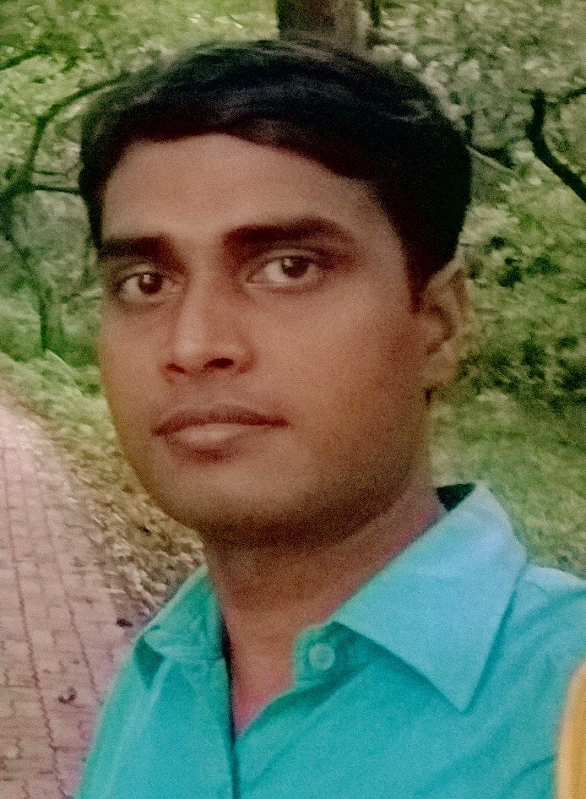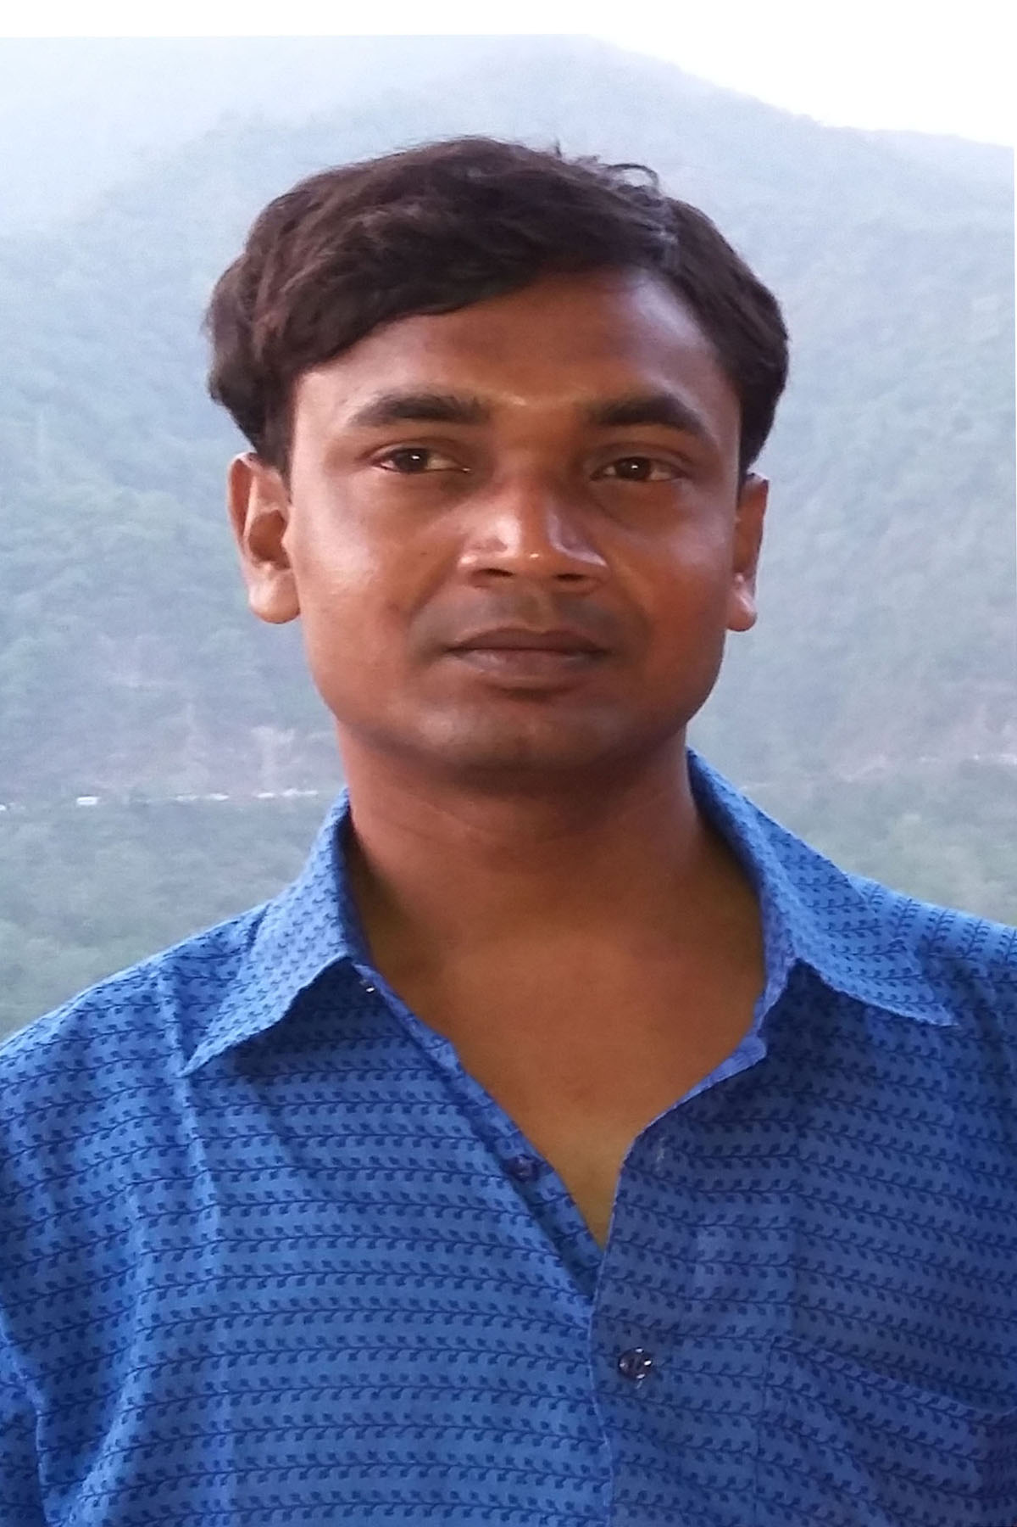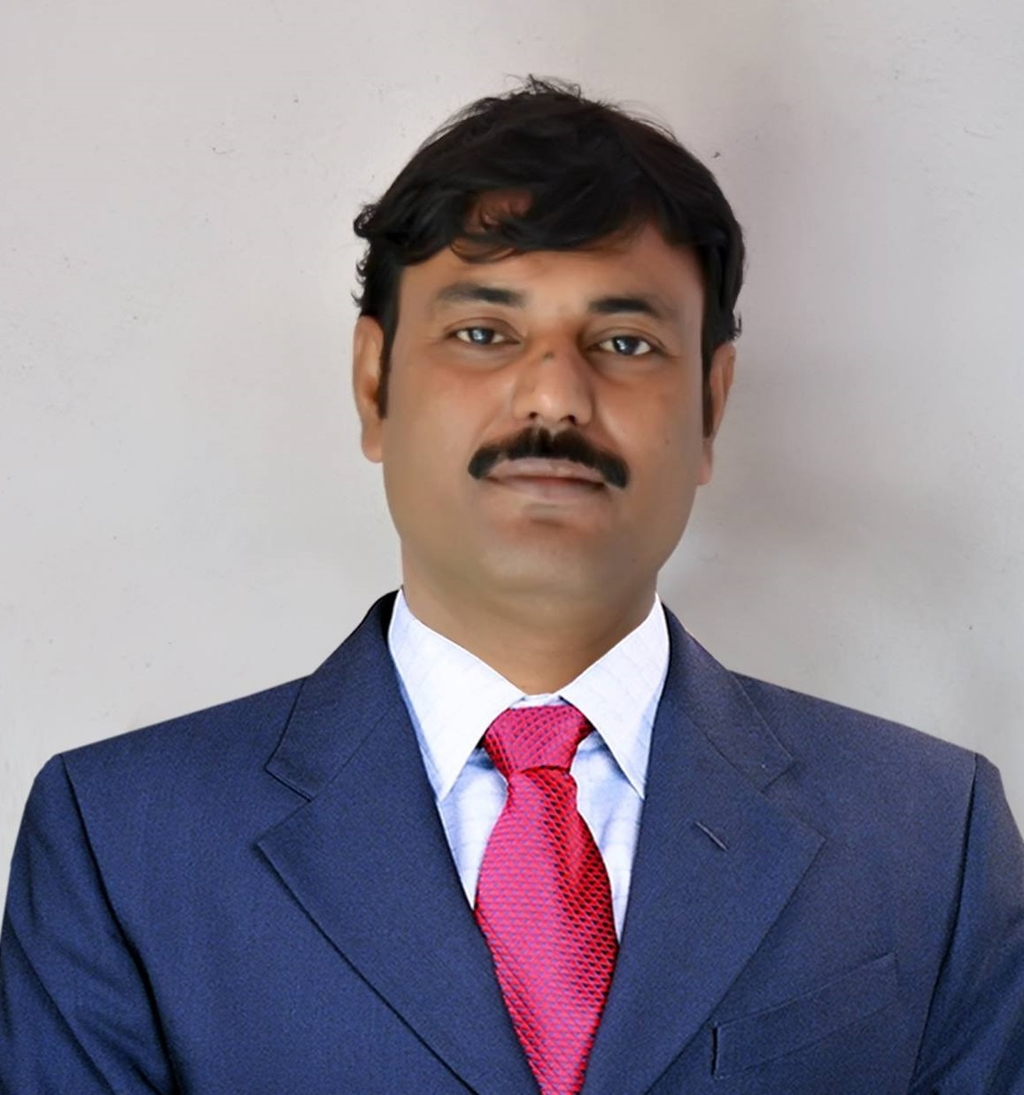 | Mr. Atanu Adhya  Assistant Professor of Sanskrit
Academic Qualifications:
*Madhyamik with Bengali, English, History, Geography, Life Science, Physical Science,
Mathematics, Work Education & Physical Education from WBBSE in 2003.

*Higher Secondary with Bengali, English, Philosophy, Political Science, History & Sanskrit from
WBCHSE in 2005.

*B.A. with Sanskrit (Hon’s), History,Philosophy ,English & Bengali from Raja Rammohun Roy Mahavidyalaya in 2008.

*M. A. in Sanskrit from The University of Burdwan in 2010.

*B.Ed. from The University of Burdwan in 2012

*M. Phil. In Sanskrit from The University of Burdwan in 2014

*NET in Sanskrit in December, 2013.

*NET in Sanskrit in December, 2014.

*SET in Sanskrit in December, 2014.
Contact Address:
Permanent: Vill- Rajhati, P.O. – Rajhati Bandar , P.S. – Khanakul , Dist. – Hooghly; West Bengal; Pin- 712417

Email: atanuadhya1988@gmail.com
Phone numbers: (+91)9614317438

Present: Dept. of Sanskrit , Raiganj University, P.O. & P.S. – Raiganj, Dist. – Uttar Dinajpur, West Bengal, Pin – 733134

Email: atanuadhya1988@gmail.com
Phone numbers: (+91)9614317438

Research Interest:
- Navya Vyakarana
- Prachin Vyakarana
- Paninian vyakarana
- Non Paninian vyakarana
- Science of language and literature
- Utility of Grammar
- Vyakarana of the Vedas
- Vyakarana of the Upanishads
- Philosophy of the Modern Sanskrit Literature
- Philosophy of the Classical Sanskrit Literature
- Philosophy of the Grammar
- Philosophy of the Puranas
- Literature Review
- Manuscriptology
- Trends of Sanskrit Literature
- Smritisastras
- Comparative Literature

- Specialization: Sanskrit Grammar,

Conference/Seminar/Workshop:
- INTERNATIONAL / NATIONAL/ STATE
1.ATTENDED AND PRESENTED INTERNATIONAL SEMINER ON “HUMAN VALUES IN INDIANPERPECTIVE”, DEPT OF SANSKRIT AND PHILOSOPHY, SIDHU-KANHO-BIRSHA UNIVERSITY, PURULIA,(2014).

2 - PARTICIPATED AND PRESENTED TWO-DAY NATIONAL SEMINER ON “SOCIETY AND CULTURE INANCIENT LITERATURE: A RETROSPECTIVE ENQUIRY”,DEPT. OF SANSKRIT, BURDWAN UNIVERSITY, BURDWAN. (2014)

3 - PARTICIPATED AND PRESENTED A PAPER IN A TWO-DAY NATIONAL SEMINER ON “SOCIETY INTHE EPIGRAPHS OF EASTERN INDIA”, ASIATIC SOCIETY, (2015)

4 - ATTENDED AND PRESENTED TWO-DAY NATIONAL SEMINER ON “HUMAN RIGHTS:CHALLENGES AND RESPONSIBILITIES”, SALDIHA COLLEGE, BANKURA(2015).

5- ATTENDED AND PRESENTED ONE-DAY NATIONAL SEMINER ON “ADHUNIKASAMAJESAMSKRTASYOPAYOGITA”, ABSLA(2015)

6 -ATTENDED AND PRESENTED ONE-DAY STATE LEVEL SEMINER ON “SANSKRIT IN SCHOOLCURRICULAM : ISSUE AND CHALLENGES”, ABSLA(2015).

7 - ATTENDED , PRESENTED AND ACTED AS DEPUTY CHAIRPERSON OF AN ACADEMIC SESSION IN THE 1ST STATE SANSKRIT CONFERENCE , ABSLA(2015).

8 - ATTENDED , PRESENTED AND CHAIRED A TECHNICAL SESSION DURING ONE-DAY NATIONAL SEMINER ON “HUMANISM IN SANSKRIT LITERATURE”, DEPARIMANT OF SANSKRIT, RAIGANJ UNIVERSITY, (2017).

9 - ATTENDED , PRESENTED AND DISTINGUISHED RESOURCE PERSON DURING ONE-DAY NATIONAL SEMINER ON “THE ROLE OF SANSKRIT IN THE UPLIFTMENT OF THE SOCIETY”, DEPARIMANT OF SANSKRIT, PATRASAYER MAHAVIDYALAYA, (2017).

A.Organizer & Joint Secretary:
i.Humanism in Sanskrit Literature, 10th March, 2017, Deptt. of Sanskrit, Raiganj University, W.B.
B.Chairperson /RESOURCE PERSON /DEPUTY CHAIRPERSON of Technical Session:
i- ATTENDED , PRESENTED AND ACTED AS DEPUTY CHAIRPERSON OF AN ACADEMIC SESSION IN THE 1ST STATE SANSKRIT CONFERENCE , ABSLA(2015)
Ii. ATTENDED , PRESENTED AND DISTINGUISHED RESOURCE PERSON DURING ONE-DAY NATIONAL SEMINER ON “THE ROLE OF SANSKRIT IN THE UPLIFTMENT OF THE SOCIETY”, DEPARIMANT OF SANSKRIT, PATRASAYER MAHAVIDYALAYA, (2017
iii Chairperson OF AN ACADEMIC SESSION IN THE .Humanism in Sanskrit Literature, 10th March, 2017, Deptt. of Sanskrit, RaiganjUniversity, W.B.

Present & Previous Employment:

1.ASSISTANT PROFESSOR OF RAIGANG UNIVERSITY (DEPARTMENT OF SANSKRIT), 22.092016 TILL NOW
2. GOVT. APPROVED PART TIME TEACHER AT PATRASAYER MAHAVIDYALAYA (DEPARTMENT OF SANSKRIT).
3.GUEST TEACHER OF BANKURA UNIVERSITY ( DEPARTMENT OF SANSKRIT).
4. PART TIME TEACHER OF GALSI RABINDRA NAJRUL COLLEGE OF EDUCATION (DEPARTMENT OF SANSKRIT)
5. GUEST TEACHER OF RAJA RAMMOHUN ROY MAHAVIDYALAYA (DEPARTMENT OF SANSKRIT).
6. GUEST TEACHER OF INDAS MAHAVIDYALAYA (DEPARTMENT OF SANSKRIT)

Administrative Experience:

Member of Board Of Studies (Under Graduate & Post Graduate), Dept. of Sanskrit, Raiganj University, Uttar Dinajpur, W.B.

Member of Board of Research Studies, Dept. of Sanskrit, Raiganj University, Uttar Dinajpur, W.B.

Member of M.Phil. Syllabus Committee, Dept. of Sanskrit, Raiganj University, Uttar Dinajpur, W.B.

Member of Under Graduate, Post Graduate & Ph.D Coursework Syllabus Committee, Dept. of Sanskrit, Raiganj University, Uttar Dinajpur, W.B.

LIST OF RESEARCH PAPERS :

- PAPER IN A JOURNAL - ISSN 2229 – 6271 – DEBASANSKRITI DEBABANI MANDIR – NATIONAL – BHAROTIYA DRISTITE PURANA AND POURANIKA MAHATVA – 2014
- PAPER IN A JOURNAL – ISSN 2347 – 8888 – SANKOLPA – NATIONAL- VYAKARANASYA AANGIKABISHALESHANATMAKADHYANAM – 2015
- PAPER IN A JOURNAL – ISSN 2393 – 8994– AMITARANJANSANKARIBALA VEDABIDYA MANDIRAM – NATIONAL – VYAKARANADARSHANE MOKSHO: ADHYANAMEKAM – 2015
- CHAPTER IN A BOOK – ISBN 978-93-84054-24-3 – DHAKA STUDENTS’ LIBRARY, KOLKATA – NATIONAL – PRACHIN BHARATIYA SIKSHABYABOSTHA: OUPANISADIK DHARANA – 2015
- CHAPTER IN A BOOK – ISBN 978-93-81795-71-2 – SANSKRIT – SANSKRIT BOOK DEPOT – NATIONAL – SANSKRITASADUKTINAM MAHATMYABICHARA – 2015
- PAPER IN A JOURNAL –ISSN 2278-9545 – COUNCIL OF EDULIGHT – INTERNATIONAL – SAHITYALAMKARE SAMAJADARPANAM – 2015
- CHAPTER IN A BOOK – ISBN 978-93-84054-24-4 – DHAKA STUDENTS’ LIBRARY, KOLKATA – NATIONAL – 2015
- PAPER IN A JOURNAL – ISSN 2347 – 8888 – SANKOLPA – NATIONAL –MUGDHABODHAVYAKARENE PANINEOTA – 2015

Other Experience:-
*1st polling officer( two times)-2013-2015
* 6th Month Certificate course –“Awareness of the Society and Inculcation of Human Values”.2007
*Participated in the District Level Youth Parliament Competition—2007-2008
*Attended the “N.S.S. SPECIAL CAMPING PROGRAMME”—2007.
*Attended the “N.S.S. SPECIAL CAMPING PROGRAMME”—2008.
*Passed the NCC Certificate ‘B’ Examination (grade B) --2008
*Attended a crash course on health education along with some incurable fatal maladies at GRNCE-2012.

