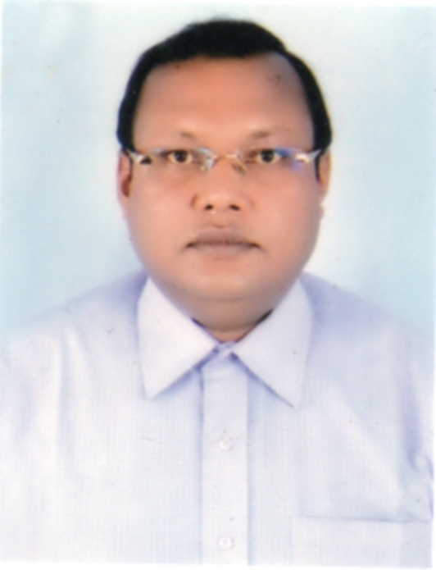 | Dr. SAMIR KUMAR MANDAL  Assistant Professor of Sanskritt
Academic Qualifications:
MA, Ph.D. , B.ED.

Contact Address:
MALANCHA PALLY (SOUTH) , BT HOSTEL ROAD , PO – MOKDUMPUR , DISTRICT – MALDA , WEST BENGAL , INDIA .
PIN - 732103

Email: iota.samir@gmail.com
Phone numbers: 09932271169 / 09474654703

Research Interest:
VEDIC STUDIES

Specialization:
VEDA

Fellowships: NIL

Award: NIL

Conference/Seminar/Organisation:

Teaching Experience:
.
SL NO | Name of post | Institution | Duration
1 | Part-Time Lecturer | Chanchal College,NBU | 12.09.2005 to 12.03.2006
2 | Assistant Teacher (Pass) | Murcha Sukhadabala High School,Malda | 13.03.2006 to  11.10.2007
3 | Assistant Teacher (PG) | Sudarshannagar PHHV High School(HS), D/Dinajpur | 12.10.2007 to  15.09.2016
4 | Assistant Professor | Raiganj University,  Uttar Dinajpur,WB. | 16.09.2016 to  Till date

Research Experience:
Ph.D. awarded in Sanskrit from Rabindra Bharati
University in the session 2014-2015.
Research Guiding Experience:

Ph.D. Scholars: Two students doing Ph.D. and one student doing M.Phil. under my supervision

Post-Doctoral – Research Associate: NIL
Completed Research Projects: NIL

Ongoing Project : NIL

Previous & Present Employment:
CHANCHAL COLLEGE (AS A PART TIME LECTURER) ,MALDA ; MURCHA SUKHADA BALA HIGH SCHOOL , MALDA ; SUDASHNNAGAR PHHV HIGH SCHOOL(HS), D/DINAJPUR ; RAIGANJ UNIVERSITY (PRESENT) .
Administrative Experience: NIL

Financial Assistances from following Organisations for attending International Conferences in abroad:

NIL
Publications:

Books: NIL

Research Papers: 2

Technical Report: NIL

Advisory Editor: NIL

Special Lectures : NIL

Keynote Addresses: NIL

Country Visited: BANGLADESH – 2015.

Editorial Board Member: NIL

REVIEWER of the following Books and Journals: NIL

Jury Member: NIL

Life Member : ITIHAS ACADEMY , DHAKA , BANGLADESH.

LIST OF PUBLICATIONS:
- Accepted for publication in Vol. 7 , March 2014 of KARATOYĀ(ISSN:2229-4880),(A Refereed and Peer Reviewed Journal Published Annually), North Bengal University Journal of Histoty.
Paper Name : Socicty as Reflected in Kauśika Sūtra : An Atharvavedic Text.
- Accepted for publication in Vol. I, Issue : II , November, 2016 of Gour Mahavidyalaya Journal of Humanities & Socilal Science (ISSN:2454-2113), Gour Mahavidyalaya, Malda,WB.
Paper Name : Contribution of Bhabani Prasad Bhattacharya and Taraknath Adhikari to the Vedas.

RESEARCH PAPERS

PARTICIPATION IN SEMINAR/CONFERENCE/WORKSHOP(UP TO 2O16):
International
- Conference : Attended and presented a paper in the University of Gour Banga, Malda, 5th & 6th April 2017.
Paper : Rajakarmaṇi in Kauśika Sūtra and its Commentary.
- Conference : Attended and presented a paper in the ITIHAS ACADEMY-DHAKA, Dhaka, Bangladesh, 28th August 2015.
Paper : Kaushiksutrer aloke Samajik Sanskar : ekti
Bishleshanatwak Paryalochona

National
- Chaired a Technical Session on Humanism in Sanskrit Literature , Raiganj University , 10th March, 2017
- Attended and presented a paper in Raiganj University , 10th March, 2017.
Paper : Human value : The Vedic perspective.
- Attended and presented a paper in A.I.O.C., 48th Session at Uttarakhand Sanskrit Unversity, Hridwar (Uttarakhand) from 12th to 14th 2016.
Paper : Concept of Gāytrī in the Vedas.
- Attended and presented a paper in University of Gourbanga, 1st October 2015.
Paper : Contribution of Bhabani Prased Bhattacharya and Taraknath Adhikari to the Vedas.
- Attended and presented a paper in A.I.O.C., 47th Session at Gauhati Unversity, Assam 2nd to 4th 2015.
Paper : POLOTICAL ELEMENTS OF THE ATHARVAVEDA AND KAUŚIKA SŪTRA
- Attended and Presented a paper in University of Gourbanga, 19th September 2014
Paper: Atharvavediya Kausiksutrer Bishaybastu o Gurutto.

- Attended in 2 day National Seminar on “Contribution of in Some Distinguished Bengalees to Sanskritic Studies” held on 30-31 January 2014 in Rabindra Bharati University , Kolkata.
- Attended in 2 day National Seminar on “Indian Intellectual Tradition : Sanskrit Grammar” held on 05-06 February 2015, in Rabindra Bharati Unversity,Kolkata.
- Attended and Participated in 5 day Workshop on “Recitation of Ancient Indian Texts” held at the School Vedic Studies, Rabaindra Bharati Unversity, Kolkata from December 27-31, 2010.
- Attended and Participated in 7 day Workshop on “Methodology for Indological Researches” held at the School Vedic Studies, Rabaindra Bharati Unversity, Kolkata from February 18-24, 2003.

Others activities :

- Certificate of various Special Coaching Programme , Labour Department, District Employment Exchange , Malda, Government of West Bengal, 24.06.2016.
- Certificate of Appreciation, Blood Donation Camp Orgnised by Vidyalay Paridarsak Samity in Association with Shelter of Malda on 08-09-2014.
- Certificate of Appreciation, Blood Donation Camp Orgnised by Ramakrishna Mission,Malda in Association with St. John Ambulance Association, Malda on 12-01-2006.
- Certificates in “PRAKSHNAPRAMANAPATRAM”(Spoken Sanskrit) Ramakrishna Mission-Sanskritakendram, Golparak, Kolkata,(03-01-2003 to 20-01-2003).
- Certificates in NSS Activities, Rabindra Bharati University,Kolkata (Session 2001-02).

Patent: NA

