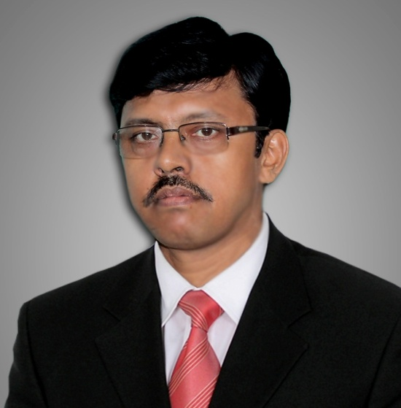 | Dr.Sujoy Kumar Mojumdar  Assistant Professor  Department of Economics  RAIGANJ UNIVERSITY  RAIGANJ-733134.  West Bengal. India  Tel. +91-9475484126  Email. skmojumdar@ gmail.com

PROFILE
------------------------------------------------------------------------------------------------------------------------------
Dr. Sujoy Kumar Mojumdar is currently working as an Assistant Professor of Economics at Raiganj University, West Bengal. Prior to joining his current position, he had worked at the National Institute of Urban Affairs (NIUA), New Delhi, Indian Institute of Mass Communication (IIMC), National Council of Applied Economic Research (NCAER), New Delhi, National Institute of Health and Family Welfare (NIH&FW) and Siliguri Jalpiguri Development Authority (SJDA). He also taught under Graduate Economics at the University of North Bengal, University of Delhi (DU) and Indra Gandhi National Open University (IGNOU). His research interests are broadly in the areas of Development Economics, Macro Economics, Labour Economics and issues related to Health Economics. He is currently teaching Economics at the UG, PG and M.Phil Level.
QUALIFICATIONS
------------------------------------------------------------------------------------------------------------------------------
PhD (Economics) Jawaharlal Nehru University 2012
M.Phil (Economics) University of North Bengal 2002
MA (Economics) University of North Bengal 1998

Areas of Interest/ Specialization
--------------------------------------------------------------------------------------------------------------------
Public Economics. Development Economics, Health Economics, Labour & Research Methodology

RECENT PUBLICATIONS
(A). Refereed Journals
- Mojumdar S K and S Ray (2013) “Viability of Regional Rural Banks in India in the Post- reform Period: A Temporal Analysis of their Financial Performance” Indian Journal of Regional Science, December , Volume XXXXV, Number 2, ISSN, 0046-9017
- Mojumdar S K (2015): Untreated Morbidity and Health care Demand among the Slum Dwellers: A case study of Urban centers in West Bengal. Journal of Health and Population: Perspectives & Issues@ National Institute of Health and Family Welfare. Government of India. Volume .38, No. 1 & 2. January-June 2015, ISSN: 0253-6803
- Mojumdar S K (2015): Trends in Maternal care Utilization in Urban India: A Temporal Analysis. Environment and Urbanization Asia. Volume. 6, No. 2, September 2015 ISSN: 0975-4253 @ Sage Publication. USA
- Mojumdar S.K (2015): Access to Medical Facilities among the Slum dwellers: A Case Study of Select Towns/Cities in West Bengal. India, Indian Journal of Regional Sciences. Volume 47 and Number 02. December. ISSN: 0046-9017,
- Mojumdar S K (2016).Financial burden of health care and catastrophic expenditure among urban households in India: Evidence from different rounds of NSS
Journal of Social and Economic Studies, @ A N Sinha Institute of Social Studies. Patna. Vol. XXVI Number .1 & 2. ISSN: 377-508
- Mojumdar S K (2017): Public Retreat and Changing Access to Inpatient Hospital Care in West Bengal. Journal of Health Management. IIMR University. @ Sage Publication. USA . Vol.19. No. 3, July-September, ISSN: 09720634
- Mojumdar S.K (2017). Socio economic disparities in utilization of maternal health care services in rural India. Journal of Economic & Social Development @Institute of Social and Economic Development. Ranchi. Vol.XIII. No.01, January- June, ISSN. 0973-886X
- Mojumdar S K (2018): Determinants of health service utilization by urban households in India: a multivariate analysis of NSSO case level data. Journal of Health Management. IIMR University. @ Sage publication. USA Volume 20 Number 2 (April-June,). ISSN. 09720634 (In Press)
B. Official reports, Working papers, surveys, etc.
- Bhide S ,Gobindan A, Bandyapadhyay S, Mondal S K, Joshi L.Ahuja V.P ,Mondira Bhattacharya and Mojumdar S K. (2013) “Agricultural Outlook and Situation Analysis Reports” Quarterly Agricultural Outlook Reports. April-June 2013. http://agrioutlookindia.ncaer.org/publications-detail.html
- Bhide S ,Gobindan A, Bandyapadhyay S, Mondal S K, Joshi L.Ahuja V.P ,Mondira Bhattacharya and Mojumdar S K.. (2013) “Agricultural Outlook and Situation Analysis Reports” Quarterly Agricultural Outlook Reports. April-June 2013. http://agrioutlookindia.ncaer.org/publications-detail.html
- Bhide S ,Gobindan A, Bandyapadhyay S, Mondal S K, Joshi L.Ahuja V.P ,Mondira Bhattacharya and Mojumdar S K.. (2013) “Agricultural Outlook and Situation Analysis Reports” Quarterly Agricultural Outlook Reports. January-March 2013. http://agrioutlookindia.ncaer.org/publications-detail.html

- Bhide S ,Gobindan A,, Mondal S K, Joshi L.Ahuja V.P ,Mondira Bhattacharya and Mojumdar S K. (2013) “Agricultural Outlook and Situation Analysis Reports” First Semi Annual Medum Term Agricultural Outlook Reports. February 2013. http://agrioutlookindia.ncaer.org/publications-detail.html

- Bhide S ,Gobindan , Mondal S K, Joshi L.Ahuja V.P ,Mondira Bhattacharya,Rajesh Kumar and Mojumdar S K. (2013) “Agricultural Outlook and Situation Analysis Reports” Quarterly Agricultural Outlook Reports. October-December 2012. http://agrioutlookindia.ncaer.org/publications-detail.html

- Bhide S.,Gobindan A, Mondal S K,Rajesh Kumar.Ahuja V.P and Mojumdar S K. (2012) “Agricultural Outlook and Situation Analysis Reports” Quarterly Agricultural Outlook Reports. July-September, 2012. http://agrioutlookindia.ncaer.org/publications-detail.html
- Bhide S.,Gobindan A, Mondal S K, Sarkar S. Ahuja V.P and Mojumdar S K. (2012) “Agricultural Outlook and Situation Analysis Reports” Quarterly Agricultural Outlook Reports. April-June , 2012 http://agrioutlookindia.ncaer.org/publications-detail.html

SEMINAR / WORKSHOPS ATTENDED/ PRESENTED
- Presented paper “Viability of Regional Rural Banks in the Post Liberalization Period in India” in a workshop on “Research Methodology & Training in Economics” held at the University of North Bengal from 22nd to 23rd March, 2002.Darjeeling.West Bengal.
- Attended International workshop on Impact Evaluation and Survey Methods workshop March 11-21, 2013. World Bank and NCAER. New Delhi
- Attended 55th Annual Conference: Indian Society of Labour Economics, 16-18 December, 2013. Jawaharlal Nehru University, New Delhi
- Presented paper in 12th Annual conference of IASSH on “Health Gender and Development “Multidisciplinary perspectives” held at the University of Lucknow, 21- 23 November 2014.
- Presented paper in Fourth Conference of Indian Health Economics and Policy Association (IHEPA) on “Health System Strengthening and Reforms in India: Retrospect and Prospect” held at the Department of Economics, University of Rajasthan, Jaipur, 13-14 February 2015.
- Attended 21st University Level Workshop on “Training in Research Methodology and Application” held at the Department of Economics , North Bengal University on 27th -28th March, 2015
- Attended in the UGC 23rd Orientation Programme at UGC Human Resource Development Centre (HRDC) at University of North Bengal, West Bengal held during 30th July-26 August 2015
- Presented a paper at the International Conference on Issues on Regional Development held at the University of Burdwan. West Bengal during 15-16 September 2015
- Presented a paper at a National Seminar on “Health care, Women Empowerment and Rural Development in India” held at A K Dasgupta Centre for Planning and Development. Department of Economics and Politics, Visva-Bharati, Santiniketan West Bengal during 20-21 November 2015.
- Paper presented at the International Seminar on “Raiganj University: Challenges and Opportunities” sponsored by the Department of Higher Education, Government of West Bengal held at Raiganj University. West Bengal 14-15 March 2016
- Paper presented at the National Seminar on Contemporary Development Issues, organized by Department of Economics, Raiganj University. West Bengal March 19-20 , 2016
- Paper presented at National Seminar on Development Perspectives for India: Emerging Issues and Challenges held at the Department of Economics, Raiganj University. West Bengal 27th March 2017.
- Organized a National Seminar as Joint Secretary on Contemporary Development Issues at the Department of Economics , Raiganj University during 14-15 March 2016
- Organized a National Seminar as Joint Secretary on Development Perspectives for India: Emerging Issues and Challenges at the Department of Economics, Raiganj University. West Bengal held on 27th March 2017.

